Name____________________________________Date_________________________
Chapter 3: The Early Inhabitants of South Carolina

True/False
Indicate whether the statement is true or false.

____ 1. The most common theory of man’s arrival in North America says he arrived by boat from Asia.

____ 2. Wooly mammoths and mastodons were found in the Paleo period.

____ 3. The Indians who lived during the Archaic period began to form settlements and became farmers.

____ 4. Tepees were a common form of Indian shelter in South Carolina.

____ 5. Paleo Indians often killed animals unnecessarily.
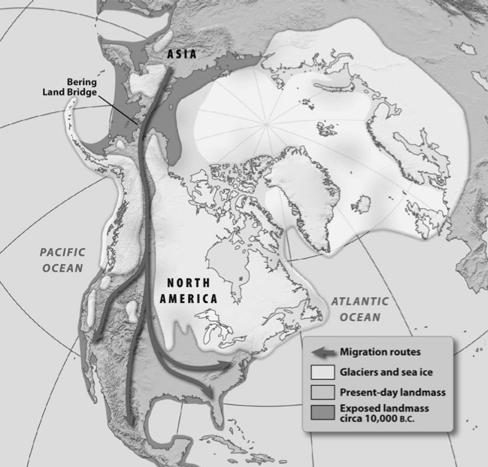
Multiple Choice
Identify the choice that best completes the statement or answers the question.

____ 1. What type of scientists study the origin and development of humans?
A. | anthropologists
B. | archaeologists
C. | economists
D. | sociologists

____ 2. Which statement BEST explains the information on the map?
A. | The British Isles were islands.
B. | There is less land in the world today.
C. | There were no glaciers in the United States.
D. | The east coast of the United States has not changed.

____ 3. Which characteristic describes the earliest peoples in North America?
A. | They were farmers.
B. | They were nomads.
C. | They were gatherers.
D. | They were fishermen.

____ 4. Which statement describes geographic conditions in North America when early people migrated from Asia?
A. | There was more dry land than there is today.
B. | There was abundant food to support more people.
C. | There were no mountains to hinder the movement of people.
D. | There was a system of rivers and streams to permit easy travel.

____ 5. What brought about a change in the diet of early people?
A. | the discovery of fire
B. | a move to a new place
C. | a longer growing season
D. | the disappearance of large animals

____ 6. What new way of acquiring food was begun during the Woodland period?
A. | farming
B. | trading
C. | fishing and herding
D. | hunting and gathering

____ 7. Which time period included the moundbuilders?
A. | Archaic period
B. | Mississippian period
C. | Paleo period
D. | Woodland period

____ 8. Why did diseases, like smallpox, affect American Indians more than Europeans?
A. | Europeans had been vaccinated against the diseases.
B. | Europeans had a natural immunity to the various diseases.
C. | The American Indians had no prior exposure to the diseases.
D. | The poverty-like conditions in which the American Indians lived caused the diseases to spread.

The Origin of Earth
A Cherokee Myth

The earth is a great island floating in a sea of water, and suspended at each of the four cardinal points by a cord hanging down from the sky vault, which is of solid rock. When the world grows old and worn out, the people will die and the chords will break and let the earth sink down into the ocean, and all will be water again. The Indians are afraid of this . . . .

When the animals and plants were first made--we do not know by whom--they were told to watch and keep awake for seven nights. . . . They tried to do this, and nearly all were awake through the first night, but the next night, several dropped off to sleep, and the third night, others were asleep, and then others, until on the seventh night, of all the animals only the owl, the panther, and one or two more were still awake. To these were given the power to see and go about in the dark, and to make prey of the birds and animals which must sleep at night. Of the trees, only the cedar, the pine, and spruce, the holly and the laurel were awake to the end, and to them it was given to be always green and to be greatest for medicine, but to the others it was said: “Because you have not endured to the end, you shall lose your hair every winter.”

Source: James Mooney, Myths of the Cherokee and Sacred Formulas of the Cherokee (Nashville: Charles and Randy Elder, 1982), pp. 239-240.

____ 9. Based on the Cherokee myth, why are cedar, pine, spruce, holly, and laurel trees evergreen?
A. | They were resting places of the owls.
B. | They remained awake for seven nights.
C. | They were the tallest of the trees on Earth.
D. | They received most of the water they needed from the ocean.

____ 10. According to the Cherokee myth, how will the world end?
A. | The world will end in an explosion or fire.
B. | The world will end when all creatures fall asleep.
C. | The world will end when all the Cherokee people are gone.
D. | The world will end when the cords break and drop the world back into the ocean.

____ 11. The main source of livelihood for nomadic tribes was
A. | vegetables
B. | large game
C. | small game
D. | fish

____ 12. What European country financed Columbus’ voyages?
A. | England
B. | France
C. | Italy
D. | Spain

Completion
Complete each statement.

1. Pottery from a prehistoric community was found on Stallings Island in the ____________________ River.

2. Paleo means ____________________.

3. Indians used the _______________________________________ as an occasion for washing away impurities and getting a new start.

Matching

Match the term with its definition.
A. | autonomy | F. | midden
B. | daub | G. | mythology
C. | exploit | H. | nomadic
D. | maize | I. | palisade
E. | matrilineal | J. | technology

____ 1. collection of stories to explain the mysteries of life

____ 2. a society in which ancestry is traced through the mother

____ 3. trash heap left by prehistoric people

Essay

1. Describe three characteristics of Indian trade with whites.

2. Describe why Indians and whites were involved in the slave trade.

Chapter 3: The Early Inhabitants of South Carolina
Answer Section

TRUE/FALSE

1. ANS: F
The most common theory of man’s arrival in North America says he came by foot from Siberia to Alaska.

PTS: 1 DIF: Application REF: Chapter 3 Section 1
TOP: Prehistoric Indians

2. ANS: T PTS: 1 DIF: Knowledge REF: Chapter 3 Section 1
TOP: Prehistoric Indians

3. ANS: F
The Indians who lived during the Archaic period were hunters and gatherers.

PTS: 1 DIF: Comprehension REF: Chapter 3 Section 1
TOP: Prehistoric Indians

4. ANS: F
The most typical dwelling was the wigwam, a circular or oblong house.

PTS: 1 DIF: Application REF: Chapter 3 Section 2
TOP: Historic Indians

5. ANS: T PTS: 1 DIF: Comprehension
REF: Chapter 3 Section 1 TOP: Prehistoric Indians

MULTIPLE CHOICE

1. ANS: A PTS: 1 DIF: Comprehension
REF: Chapter 3 Section 1 TOP: Prehistoric Indians

2. ANS: B PTS: 1 DIF: Analysis REF: Chapter 3 Section 1
TOP: Prehistoric Indians

3. ANS: B PTS: 1 DIF: Comprehension
REF: Chapter 3 Section 1 TOP: Prehistoric Indians

4. ANS: A PTS: 1 DIF: Application REF: Chapter 3 Section 1
TOP: Prehistoric Indians

5. ANS: D PTS: 1 DIF: Application REF: Chapter 3 Section 1
TOP: Prehistoric Indians

6. ANS: A PTS: 1 DIF: Knowledge REF: Chapter 3 Section 1
TOP: Prehistoric Indians

7. ANS: B PTS: 1 DIF: Knowledge REF: Chapter 3 Section 1
TOP: Prehistoric Indians

8. ANS: C PTS: 1 DIF: Analysis REF: Chapter 3 Section 2
TOP: Historic Indians

9. ANS: B PTS: 1 DIF: Comprehension
REF: Chapter 3 Section 2 STA: 8-1.1 TOP: Historic Indians

10. ANS: D PTS: 1 DIF: Comprehension
REF: Chapter 3 Section 2 TOP: Historic Indians

11. ANS: B PTS: 1 DIF: Application REF: Chapter 3 Section 1
TOP: Prehistoric Indians

12. ANS: D PTS: 1 DIF: Knowledge REF: Chapter 3 Section 3
TOP: Early Explorers

COMPLETION

1. ANS: Savannah

PTS: 1 DIF: Application REF: Chapter 3 Section 1
TOP: Prehistoric Indians

2. ANS: very old

PTS: 1 DIF: Comprehension REF: Chapter 3 Section 1
TOP: Prehistoric Indians

3. ANS: Green Corn Ceremony

PTS: 1 DIF: Comprehension REF: Chapter 3 Section 2
TOP: Historic Indians

MATCHING

1. ANS: G PTS: 1 DIF: Knowledge REF: Chapter 3 Section 2
TOP: Vocabulary

2. ANS: E PTS: 1 DIF: Knowledge REF: Chapter 3 Section 3
TOP: Vocabulary

3. ANS: F PTS: 1 DIF: Knowledge REF: Chapter 3 Section 2
TOP: Vocabulary

ESSAY

1. ANS:
-Whites wanted animal skins to sell in Europe.
-The Indians were willing to provide skins for axes, knives, guns, beads, pots, and baskets.
-Guns and knives made it easier to kill and skin animals.
-The trade with the Indians changed the economy of the village.
-Conflict over trade caused many wars between Indians and whites.
-Large numbers of animals were killed only for their skins.

PTS: 1 DIF: Comprehension REF: Chapter 3 Section 2
TOP: Historic Indians

2. ANS:
They both profited greatly and some white Carolinians made large fortunes by selling captured Indians. The Indians received English cloth, tools, trinkets and rum for capturing other Indians. Slavery became a business for some Indians and some South Carolinians.

PTS: 1 DIF: Comprehension REF: Chapter 3 Section 3
TOP: Historic Indians

